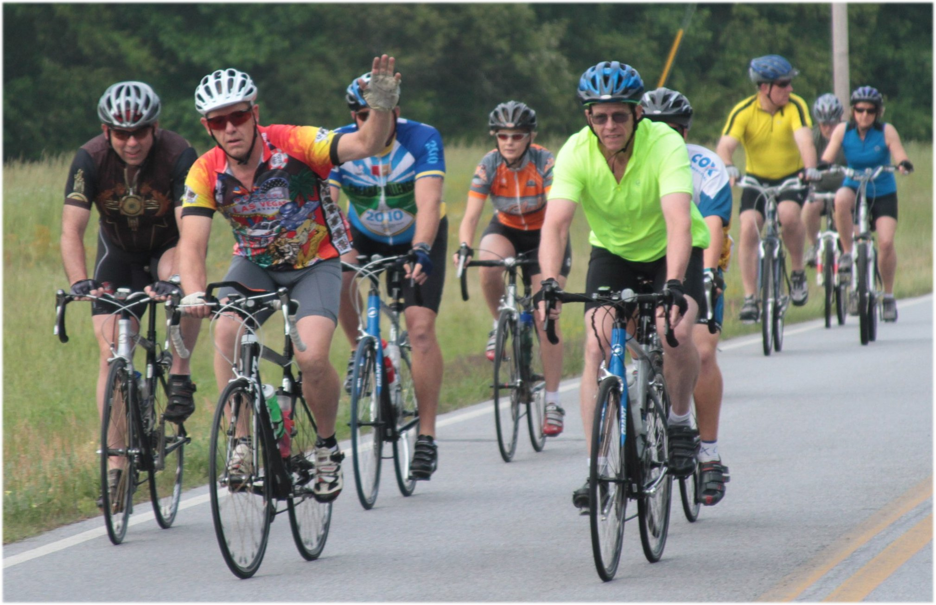
The 8th Annual

Roopville Ramble

Sponsorship Opportunities

Complete event information at http://www.RoopvilleRamble.org
-------------------------------------------------------------------
PLATINUM – INQUIRE !

“Gold Rest Stop” Level Sponsorship - $500
Your company logo on event T-shirt, website as link to your website, and event signage at rest stops. Includes 3 pre-registered entries and 3 t-shirts.

“Silver Special” Level Sponsorship - $300
Your company name on event website, as a link to your site
Logo on T-shirt, includes 2 pre-registered entries and 2 shirts

“Bronze Basic” Level Sponsorship - $200
Your company name on event website
Company name on back of shirt, includes 1 pre-registered entry and 1 shirt
---------------------------------------------------------------------------------------------------------------------

Event Check-in is from 6:30 am – 8:00 am. The Ride will have a mass start at 8 am
T-shirt pick up will be Saturday May 20, 2017, 7 am - 2 pm at start/finish at the Roopville Baptist Church.

Friday, April 14th is the deadline for advertising on our T-shirts.
NOTE – Company signage must be provided by you (the sponsor) by Friday May 12, 2017.
Deliver signs to Perpetual Motion Bicycles, Inc. on Maple Street in Carrollton.

The Roopville Ramble looks forward to bringing hundreds of bicycle riders from all over the Southeast to tour the beautiful rolling countryside of Carroll and Heard Counties. This year proceeds will benefit Camp Sunshine - providing respite, support, joy and hope to children with life-threatening illnesses and their immediate families through various stages of a child’s illness.

If you, or anyone within your organization, has interest in participating in this year’s ride, please take advantage of the entries available in the sponsorship package you select. All sponsor participants MUST be pre-registered.

Mail this form WITH rider applications for each participant from your organization, along with your check made out to Roopville Ramble to:

Roopville Ramble, c/o Perpetual Motion Bicycles, Inc., 1002 Maple Street, Carrollton, GA 30117.

Upon choosing level, please email your logo and web URL to info.sponsor@roopvilleramble.org
-----------------------------------------------------------------------------------------------------------------------------------------------------------------
2017 SPONSORSHIP FORM FOR THE ROOPVILLE RAMBLE – Saturday May 20, 2017

Sponsor Name ________________________________Contact Person___________________________________

Address _____________________________________ Phone(s) ________________________________________

Email address ________________________________ Number of event participants from this sponsor _______

Sponsorship level (circle one) PLATINUM GOLD SILVER BRONZE

Sponsor’s web address __________________________________________________________________________

Amount Included _________ Number of T-Shirts needed* S____ M_____ L_____ XL_____
*Note – if you have riders joining us, the t-shirts are part of the rider registration.

